**6. The French**

**Program Name: French.java Input File: french.dat**

The French are antagonizing King Arthur. They are trying to launch cannonballs at him. Consider the cannon to be a position (0,0) and King Arthur’s position to be (x, y) in the coordinate plane, where x, y can be negative. 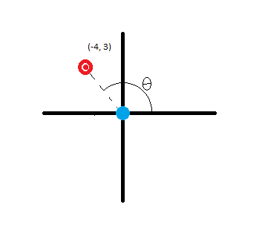

Sir Arthur is at the red target, the French at are the blue. Tell the French at what velocity (v) and angle (in degrees) to turn the cannon (Θ).

http://www4c.wolframalpha.com/Calculate/MSP/MSP161911a3g2d370hbiib8e0000595b0a1c3aci20h9?MSPStoreType=image/gif&s=61&w=61&h=33Given (x,y) and:

Φ (radians) =

http://www4a.wolframalpha.com/Calculate/MSP/MSP43681a3g3g85489aa80a00001hfged48729fegha?MSPStoreType=image/gif&s=62&w=36&h=20And

v =

http://www4a.wolframalpha.com/Calculate/MSP/MSP14571a3g40aedgid235g00002bb3f659fc2da460?MSPStoreType=image/gif&s=57&w=66&h=28And

r =

g = 9.81

http://www4b.wolframalpha.com/Calculate/MSP/MSP40501a3g3hc0965a91i100000d96hec6374ad275?MSPStoreType=image/gif&s=58&w=51&h=36And

Θ (degrees) =

Input

An integer N representing the number of data sets to follow. Each data set will have the x and y position of King Arthur. (in meters, they are French after all)

Output

The velocity (in meters per second) that the French need to fire the cannon and at what angle they should turn it to antagonize King Arthur (to 5 decimal places)

**Assumptions**

Angles below the x axis will be negative.

From physics, you may recognize that this model assumes the cannon is at a 45 degree angle to the ground, assume the cannon cannot move from this position.

Example Input File

3

-4 3.0

3 -4

0 15

Example Output To Screen

Velocity: 7.00357 m/s Angle: 143.13010 degrees

Velocity: 7.00357 m/s Angle: -53.13010 degrees

Velocity: 12.13054 m/s Angle: 90.00000 degrees